# Plan of Star Schema:

Please see below a diagram detailing the plan of the star schema that will be used for the Police data warehouse. The information highlights the fact and the dimension tables that will be implemented .

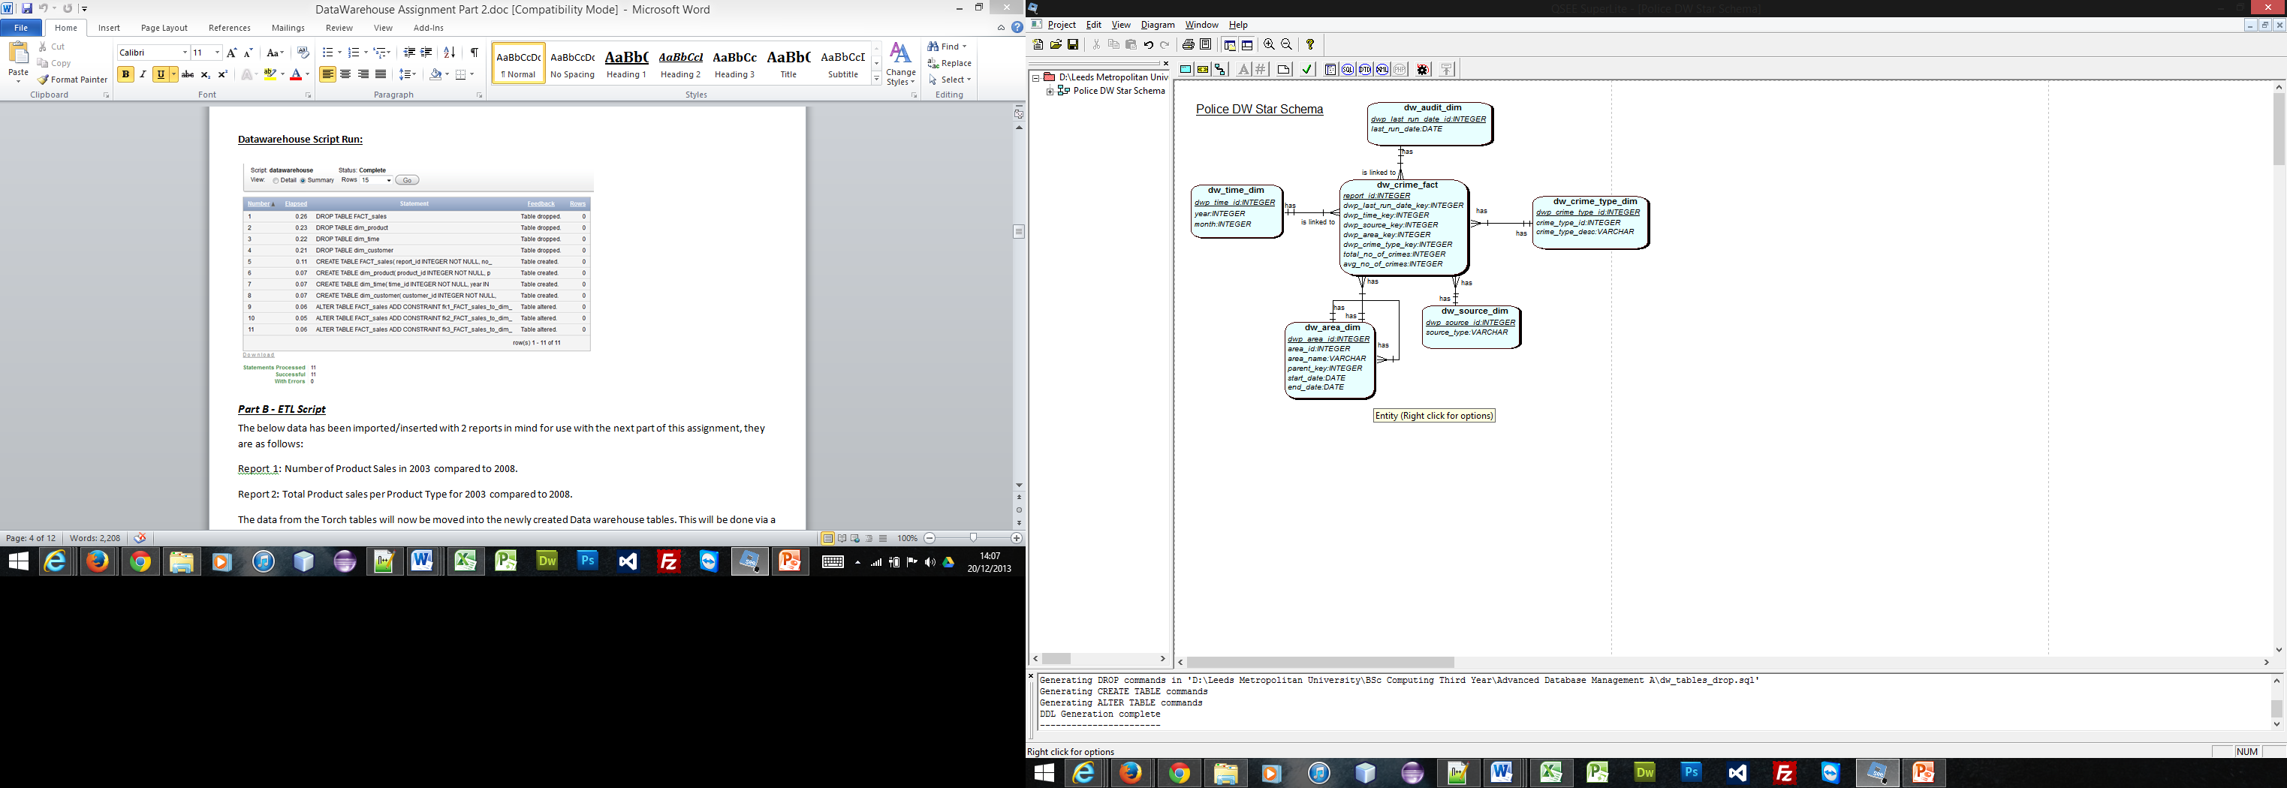

The two Reports that will be generated are:

1. Total number of Anti-Social Behaviour crimes per area during Christmas in year 2011 compared to 2012.
2. Average number of crimes in year 2011 compared to 2012.

A recursive query has been used in the ***dw_area_dim*** table to show the different area levels in a hierarchical way and to identify where they are linked with. For example, by looking at operational data we can identify the following concept

**Country -> County -> Town -> Division**

UK -> West Yorkshire -> Leeds - > AAN_HP

This approach can be used for any future data to be added in the data warehouse as well as understanding which area they maybe relating to.

**Plan of the data in the fact and dimension tables as detailed below:**

**dw_source_dim**

|  |  |
| --- | --- |
| dwp_source_id | source_type |
| 1 | PRCS Operational Data |
| 2 | Crime Data Spread Sheet |

**dw_time_dim**

|  |  |  |
| --- | --- | --- |
| dwp_time_id | year | month |
| 1 | 2013 |  |
| 2 | 2012 |  |
| 3 | 2011 |  |
| 4 | 2013 | 03 |
| 5 | 2013 | 02 |
| 6 | 2012 | 12 |
| 7 | 2012 | 11 |
| 8 | 2012 | 10 |
| 9 | 2012 | 03 |
| 10 | 2012 | 02 |
| 11 | 2011 | 12 |
| 12 | 2011 | 11 |
| 13 | 2011 | 10  This dim table will highlight the last run date of when information was loaded in the data warehouse. Clearly this is crucial as when Police want to view the data that was loaded the day before then information can be filtered to the appropriate date to view this information. |

**dw_audit_dim**

|  |  |
| --- | --- |
| dwp_last_run_date_id | last_run_date |
| -1 |  |
| 1 | 18/12/2013 |
| 2 | 19/12/2013 |
| 3 | 20/12/2013 |

**dw_crime_type_dim**

|  |  |  |
| --- | --- | --- |
| dwp_crime_type_id | crime_type_id | crime_type_desc |
| -1 | -1 | No Crime Type |
| 1 | 100 | Anti-Social Behaviour |
| 2 | 101 | Burglary |
| 3 | 102 | Car Theft |
| 4 | 103 | Criminal Damage and Arson |
| 5 | 104 | Drugs |
| 6 | 105 | Drugs Offence |
| 7 | 106 | Drunk and Disorder |
| 8 | 107 | Fraud |
| 9 | 108 | Forgery |
| 10 | 109 | Other Crime |
| 11 | 110 | Other Theft |
| 12 | 111 | Public Disorder and weapons |
| 13 | 112 | Robbery |
| 14 | 113 | Shoplifting |
| 15 | 114 | Vehicle Crime |
| 16 | 115 | Violent Crime |

**dw_area_dim**

|  |  |  |  |  |  |
| --- | --- | --- | --- | --- | --- |
| dwp_area_id | area_id | area_name | parent_key | start_dt | end_dt |
| -1 | -1 | No Area Type |  |  |  |
| 2 | 2 | UK |  | 19/12/2013 |  |
| 5 | 5 | LANCASHIRE | 2 | 19/12/2013 |  |
| 9 | 9 | BLACKPOOL | 5 | 19/12/2013 |  |
| 3 | 3 | MANCHESTER | 5 | 19/12/2013 |  |
| 1 | 1 | WEST YORKSHIRE | 2 | 19/12/2013 |  |
| 6 | 6 | HALIFAX | 1 | 19/12/2013 |  |
| 4 | 4 | LEEDS | 1 | 19/12/2013 |  |
| 11 | 11 | AAN_HP | 4 | 19/12/2013 |  |
| 10 | 10 | BA_BRH | 4 | 19/12/2013 |  |
| 8 | 8 | CAN_CH | 4 | 19/12/2013 |  |
| 7 | 7 | CAN_CITY | 4 | 19/12/2013 |  |

**dw_crime_fact**

|  |  |  |  |  |  |  |  |
| --- | --- | --- | --- | --- | --- | --- | --- |
| report_id | dwp_last_run_date_key | dwp_time_key | dwp_source_key | dwp_area_key | dwp_crime_type_key | total_no_of_crimes | Avg_no_of_crimes |
| 1 | 1 | 3 | 2 | 11 | 3 | 45 | 9 |
| 2 | 1 | 4 | 2 | 10 | 5 | 55 |  |
| 3 | 1 | 8 | 2 | 8 | 14 | 17 |  |
| 4 | 2 | 2 | 2 | 7 | 15 | 21 |  |
| 5 | 2 | 3 | 1 | 10 | 3 | 27 | 5 |

Report 1: Total number of Anti-Social Behaviour crimes per area during Christmas in year 2011 compared to 2012.

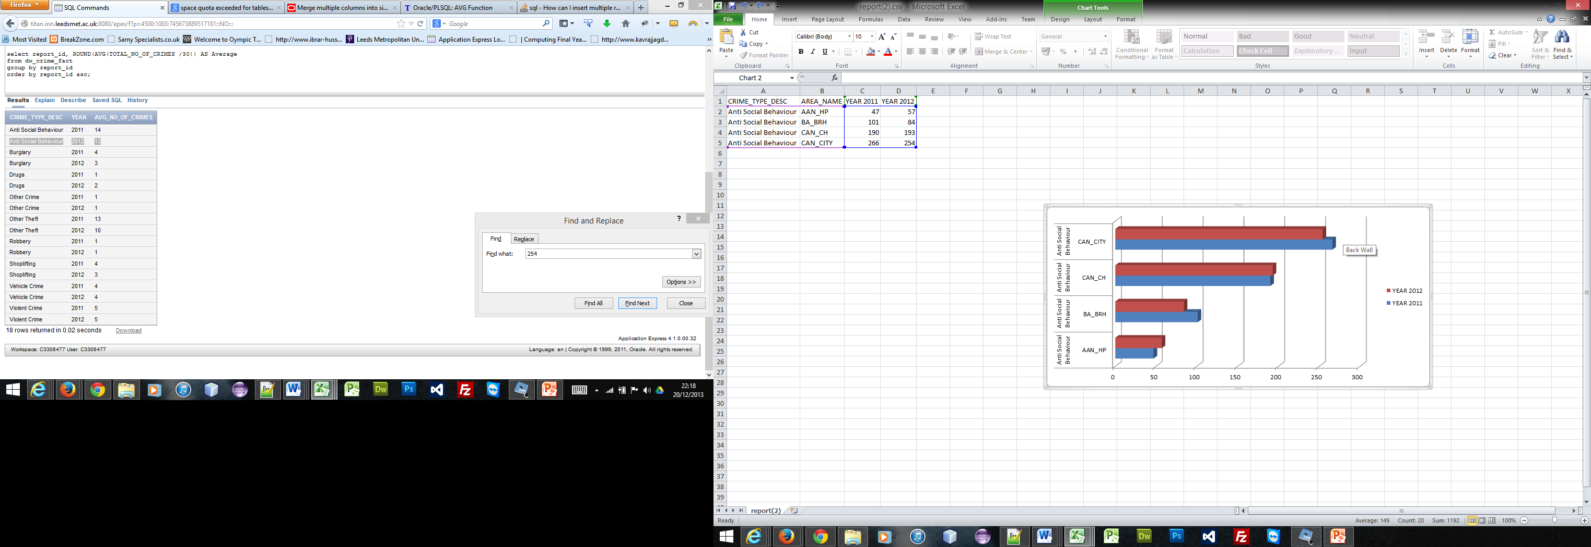

Report 2: Average number of crimes in year 2011 compared to 2012.

